**Lab8 – Understanding Performance tiers of Storage Disks - Azure**

**Disks storage for Azure Windows VMs**

Just like any other computer, virtual machines in Azure use disks as a place to store an operating system, applications, and data. All Azure virtual machines have at least two disks – a Windows operating system disk and a temporary disk. The operating system disk is created from an image, and both the operating system disk and the image are virtual hard disks (VHDs) stored in an Azure storage account. Virtual machines also can have one or more data disks, that are also stored as VHDs.

## Disks used by VMs

Let's take a look at how the disks are used by the VMs.

### Operating system disk

Every virtual machine has one attached operating system disk. It's registered as a SATA drive and labeled as the C: drive by default. This disk has a maximum capacity of 2048 gigabytes (GB).

### Temporary disk

Each VM contains a temporary disk. The temporary disk provides short-term storage for applications and processes and is intended to only store data such as page or swap files. Data on the temporary disk may be lost during a [maintenance event](https://docs.microsoft.com/en-us/azure/virtual-machines/windows/manage-availability?toc=%2fazure%2fvirtual-machines%2fwindows%2ftoc.json#understand-vm-reboots---maintenance-vs-downtime) or when you [redeploy a VM](https://docs.microsoft.com/en-us/azure/virtual-machines/windows/redeploy-to-new-node?toc=%2fazure%2fvirtual-machines%2fwindows%2ftoc.json). During a successful standard reboot of the VM, the data on the temporary drive should persist. However, there are cases where the data may not persist, such as moving to a new host. Accordingly, any data on the temp drive should not be data that is critical to the system.

The temporary disk is labeled as the D: drive by default and it used for storing pagefile.sys. To remap this disk to a different drive letter, see [Change the drive letter of the Windows temporary disk](https://docs.microsoft.com/en-us/azure/virtual-machines/windows/change-drive-letter). The size of the temporary disk varies, based on the size of the virtual machine. For more information, see [Sizes for Windows virtual machines](https://docs.microsoft.com/en-us/azure/virtual-machines/windows/sizes).

For more information on how Azure uses the temporary disk, see [Understanding the temporary drive on Microsoft Azure Virtual Machines](https://blogs.msdn.microsoft.com/mast/2013/12/06/understanding-the-temporary-drive-on-windows-azure-virtual-machines/)

### Data disk

A data disk is a VHD that's attached to a virtual machine to store application data, or other data you need to keep. Data disks are registered as SCSI drives and are labeled with a letter that you choose. Each data disk has a maximum capacity of 4,095 GB, managed disks have a maximum capacity of 32,767 GiB. The size of the virtual machine determines how many data disks you can attach to it and the type of storage you can use to host the disks.

Azure creates an operating system disk when you create a virtual machine from an image. If you use an image that includes data disks, Azure also creates the data disks when it creates the virtual machine. Otherwise, you add data disks after you create the virtual machine.

You can add data disks to a virtual machine at any time, by **attaching** the disk to the virtual machine. You can use a VHD that you've uploaded or copied to your storage account, or use an empty VHD that Azure creates for you. Attaching a data disk associates the VHD file with the VM by placing a 'lease' on the VHD so it can't be deleted from storage while it's still attached.

## About VHDs

The VHDs used in Azure are .vhd files stored as page blobs in a standard or premium storage account in Azure. For details about page blobs, see [Understanding block blobs and page blobs](https://docs.microsoft.com/en-us/rest/api/storageservices/Understanding-Block-Blobs--Append-Blobs--and-Page-Blobs/). For details about premium storage, see [High-performance premium storage and Azure VMs](https://docs.microsoft.com/en-us/azure/virtual-machines/windows/premium-storage).

Azure supports the fixed disk VHD format. The fixed format lays the logical disk out linearly within the file, so that disk offset X is stored at blob offset X. A small footer at the end of the blob describes the properties of the VHD. Often, the fixed-format wastes space because most disks have large unused ranges in them. However, Azure stores .vhd files in a sparse format, so you receive the benefits of both the fixed and dynamic disks at the same time. For more information, see [Getting started with virtual hard disks](https://technet.microsoft.com/library/dd979539.aspx).

All VHD files in Azure that you want to use as a source to create disks or images are read-only, except the .vhd files uploaded or copied to Azure storage by the user (which can be either read-write or read-only). When you create a disk or image, Azure makes copies of the source .vhd files. These copies can be read-only or read-and-write, depending on how you use the VHD.

When you create a virtual machine from an image, Azure creates a disk for the virtual machine that is a copy of the source .vhd file. To protect against accidental deletion, Azure places a lease on any source .vhd file that’s used to create an image, an operating system disk, or a data disk.

Before you can delete a source .vhd file, you’ll need to remove the lease by deleting the disk or image. To delete a .vhd file that is being used by a virtual machine as an operating system disk, you can delete the virtual machine, the operating system disk, and the source .vhd file all at once by deleting the virtual machine and deleting all associated disks. However, deleting a .vhd file that’s a source for a data disk requires several steps in a set order. First you detach the disk from the virtual machine, then delete the disk, and then delete the .vhd file.

**Warning**

If you delete a source .vhd file from storage, or delete your storage account, Microsoft can't recover that data for you.

## Types of disks

Azure Disks are designed for 99.999% availability. Azure Disks have consistently delivered enterprise-grade durability, with an industry-leading ZERO% Annualized Failure Rate.

There are three performance tiers for storage that you can choose from when creating your disks -- Premium SSD Disks, Standard SSD, and Standard HDD Storage. Also, there are two types of disks -- unmanaged and managed.

### Standard HDD disks

Standard HDD disks are backed by HDDs, and deliver cost-effective storage. Standard HDD storage can be replicated locally in one datacenter, or be geo-redundant with primary and secondary data centers. For more information about storage replication, see [Azure Storage replication](https://docs.microsoft.com/en-us/azure/storage/common/storage-redundancy).

For more information about using Standard HDD disks, see [Standard Storage and Disks](https://docs.microsoft.com/en-us/azure/virtual-machines/windows/standard-storage).

### Standard SSD disks

Standard SSD disks are designed to address the same kind of workloads as Standard HDD disks, but offer more consistent performance and reliability than HDD. Standard SSD disks combine elements of Premium SSD disks and Standard HDD disks to form a cost-effective solution best suited for applications like web servers that do not need high IOPS on disks. Where available, Standard SSD disks are the recommended deployment option for most workloads. Standard SSD disks are available as Managed Disks in all regions but are currently only available with the locally redundant storage (LRS) resiliency type.

### Premium SSD disks

Premium SSD disks are backed by SSDs, and delivers high-performance, low-latency disk support for VMs running I/O-intensive workloads. Typically you can use Premium SSD disks with sizes that include an "s" in the series name. For example, there is the Dv3-Series and the Dsv3-series, the Dsv3-series can be used with Premium SSD disks. For more information, please see [Premium Storage](https://docs.microsoft.com/en-us/azure/virtual-machines/windows/premium-storage).

### Unmanaged disks

Unmanaged disks are the traditional type of disks that have been used by VMs. With these disks, you create your own storage account and specify that storage account when you create the disk. Make sure you don't put too many disks in the same storage account, because you could exceed the [scalability targets](https://docs.microsoft.com/en-us/azure/storage/common/storage-scalability-targets) of the storage account (20,000 IOPS, for example), resulting in the VMs being throttled. With unmanaged disks, you have to figure out how to maximize the use of one or more storage accounts to get the best performance out of your VMs.

### Managed disks

Managed Disks handles the storage account creation/management in the background for you, and ensures that you do not have to worry about the scalability limits of the storage account. You simply specify the disk size and the performance tier (Standard/Premium), and Azure creates and manages the disk for you. As you add disks or scale the VM up and down, you don't have to worry about the storage being used.

You can also manage your custom images in one storage account per Azure region, and use them to create hundreds of VMs in the same subscription. For more information about Managed Disks, see the [Managed Disks Overview](https://docs.microsoft.com/en-us/azure/virtual-machines/windows/managed-disks-overview).

We recommend that you use Azure Managed Disks for new VMs, and that you convert your previous unmanaged disks to managed disks, to take advantage of the many features available in Managed Disks.

### Disk comparison

The following table provides a comparison of Standard HDD, Standard SSD, and Premium SSD for unmanaged and managed disks to help you decide what to use. Sizes denoted with an asterisk are currently in preview.

If you have required more details about storage please go through below link.

<https://docs.microsoft.com/en-us/azure/virtual-machines/windows/about-disks-and-vhds>

**Topology**

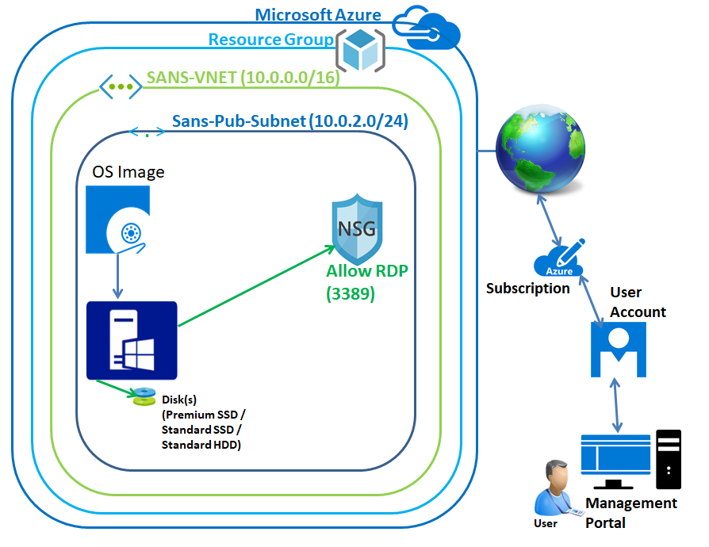

In Azure Portal, click **“Resource Groups”**

Click **“Add”** to create new **“Resource groups”**.

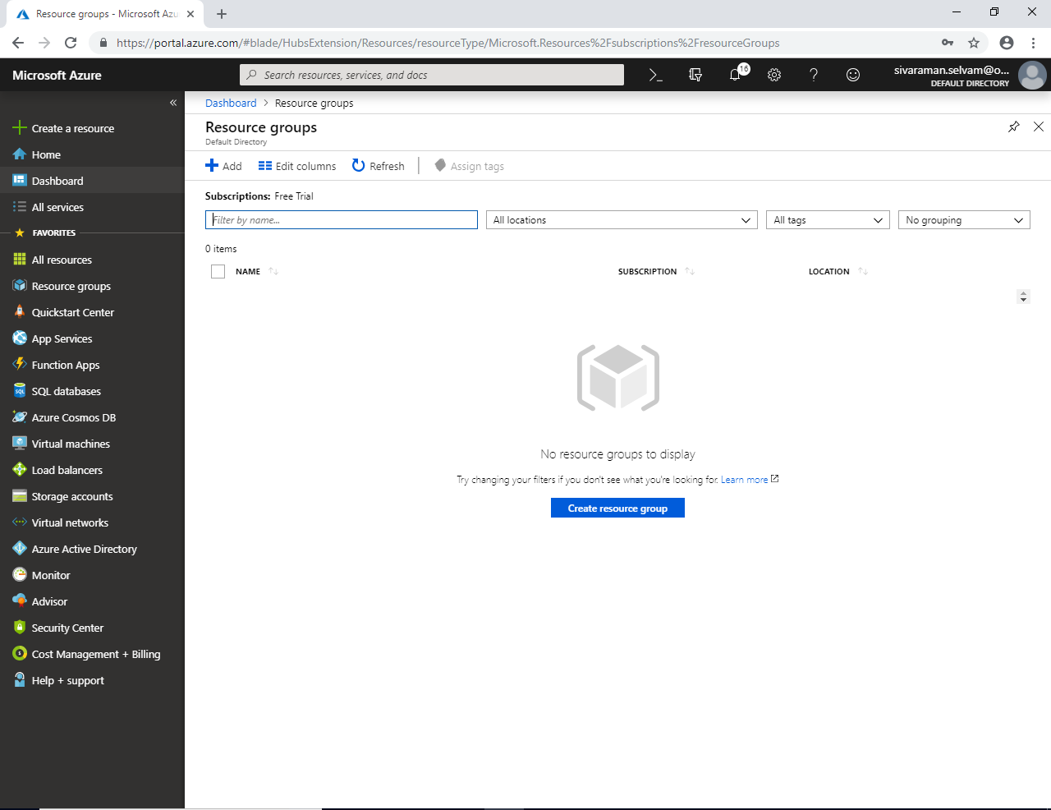

While create new **“Resource Group”** type the **“Resource group name”** as **“SansboundAzureClass”**.

Select **“Subscription”** and **“Resource group location”**.

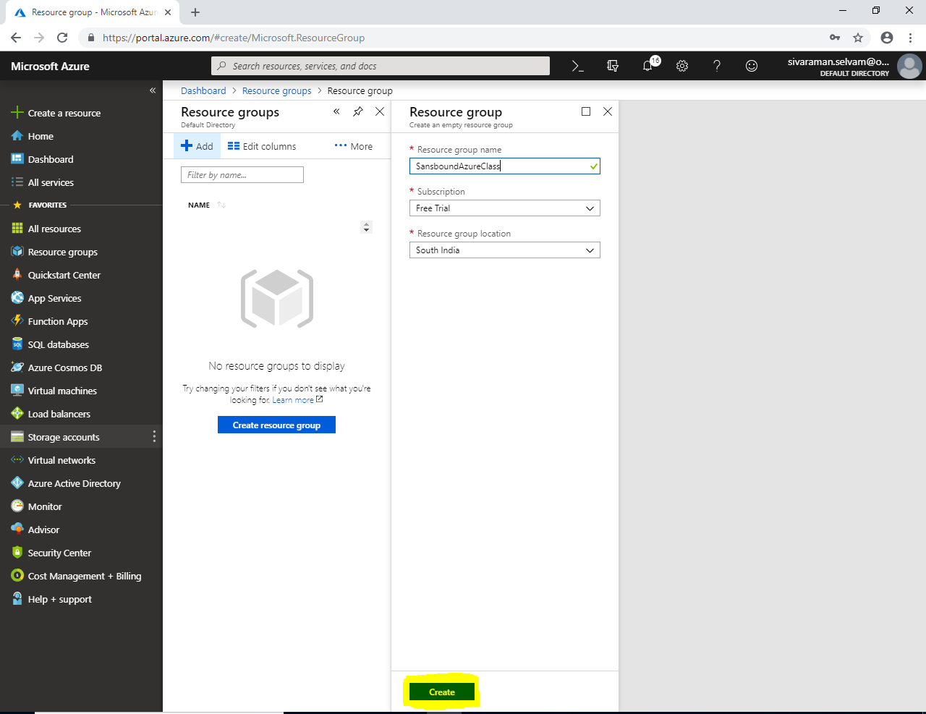

Click **“Create”**.

In **“Resource groups”** click **“Refresh”** to view newly created **“Resource Group”**.

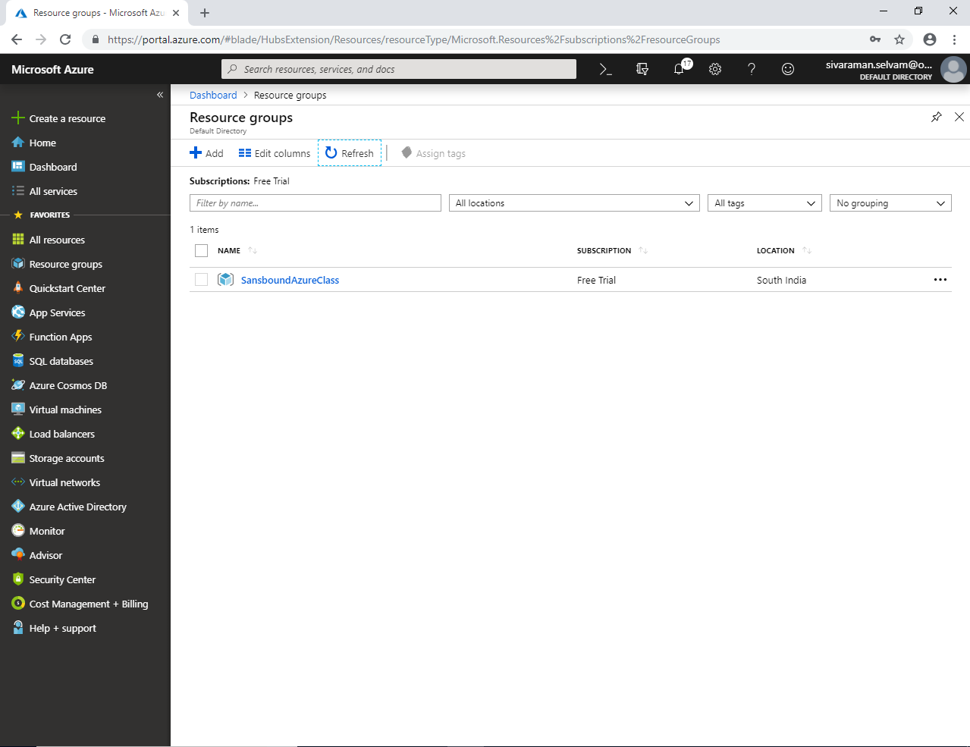

Now I have required to create a new **“VNET”**, so click **“Virtual networks”** in left side panel.

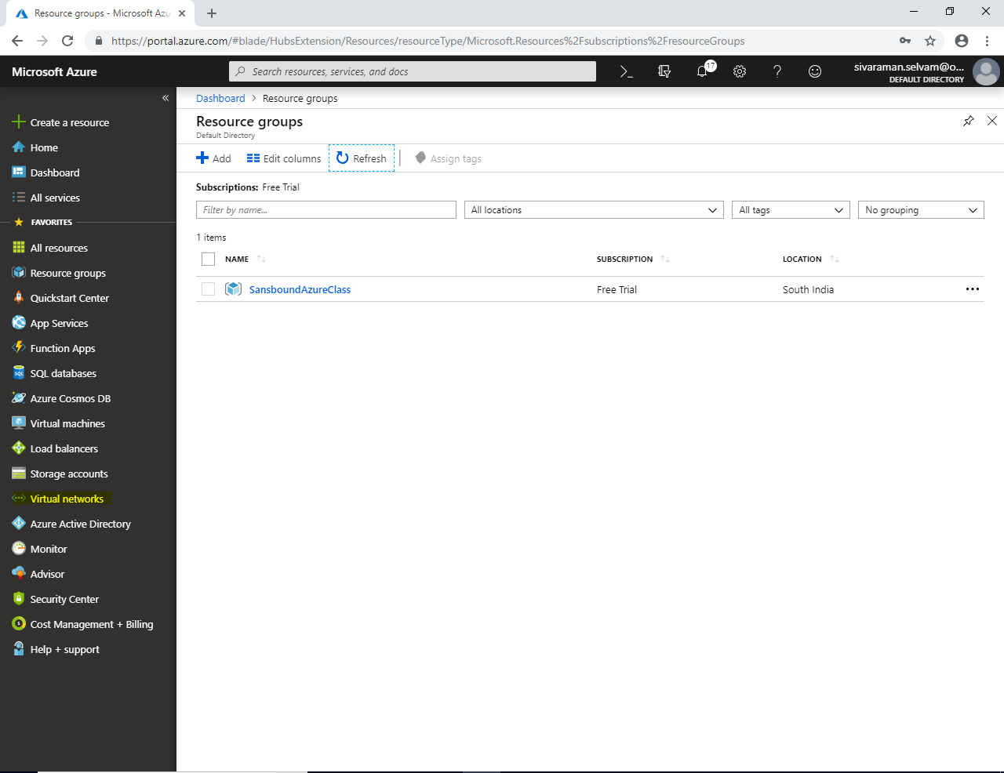

Click **“Add”**.

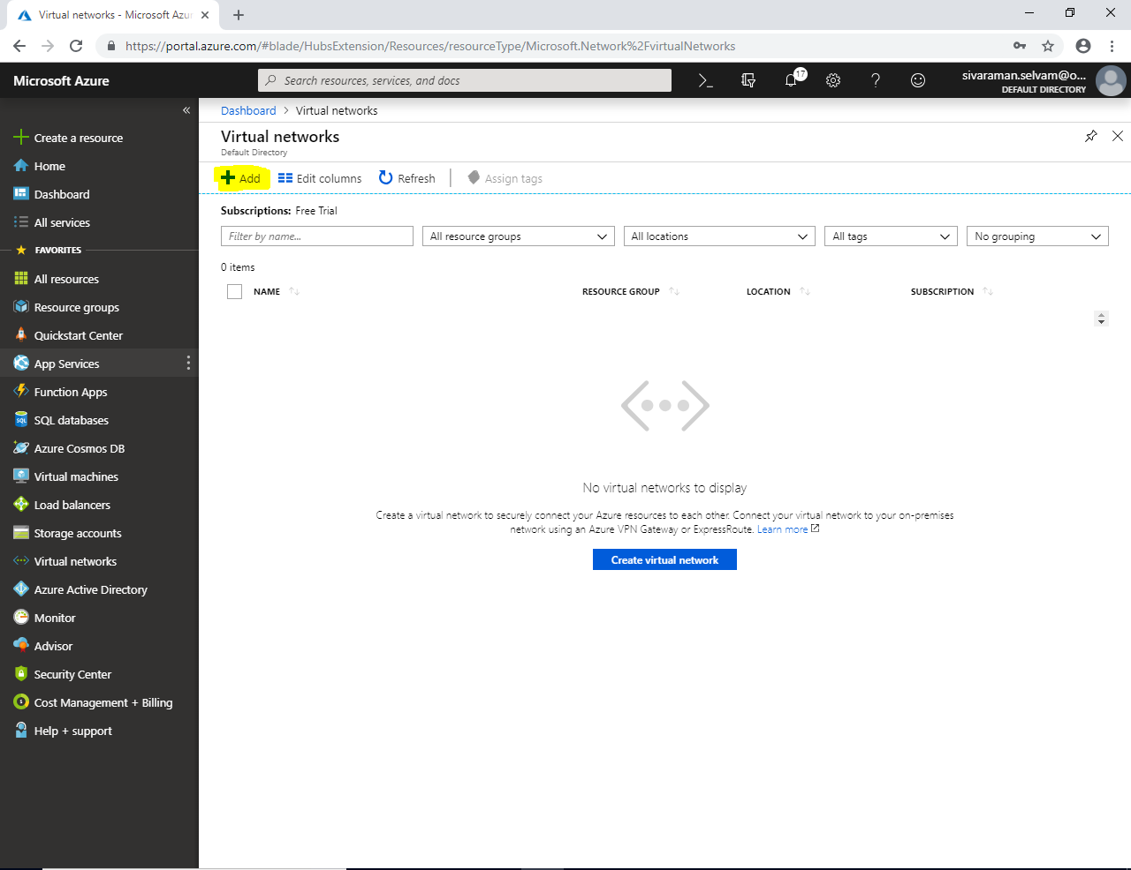

While creating **“Virtual network”**

Type **“Virtual network name”** as **“SANS-VNET”**.

Type **“Address space”** as **“10.0.0.0/16”**.

Subscription as **“Free Trial”**.

Select **“Resource group”** as **“SansboundAzureClass”**.

Location **“South India”**.

Subnet **“Sans-Pub-Subnet”**.

Type “Address range” for the subnet as **“10.0.2.0/24”**.

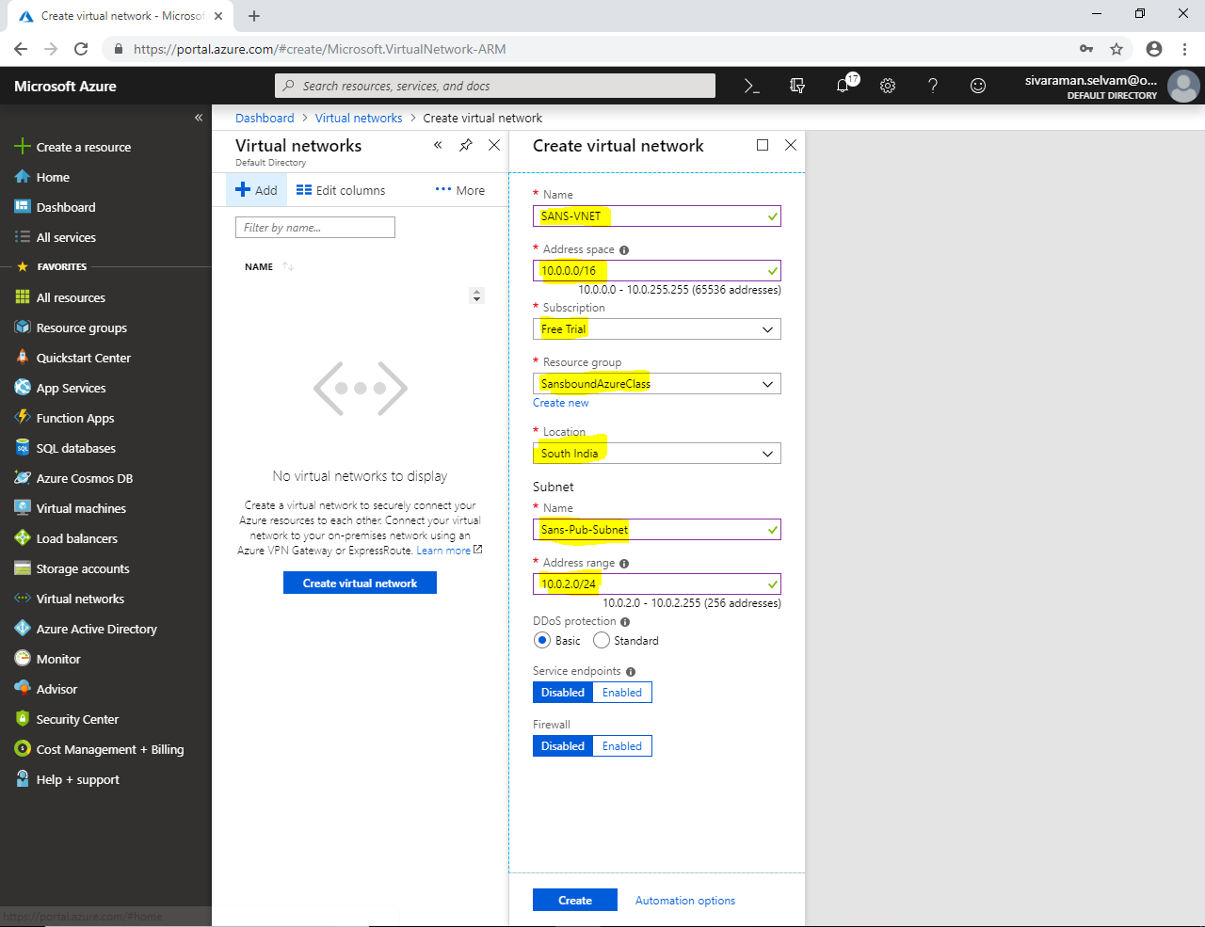

Click **“Create”**.

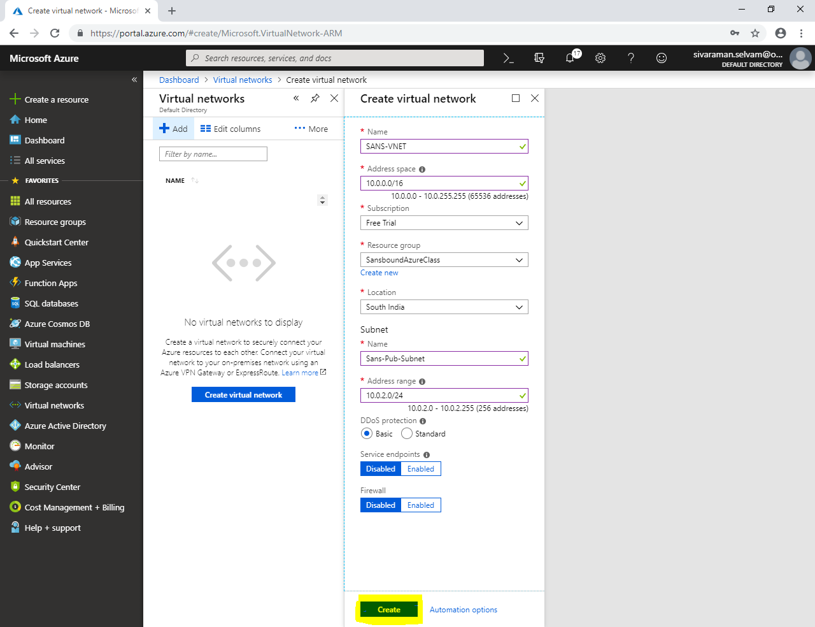

In **“Virtual networks”**

Click on **“SANS-VNET”.**

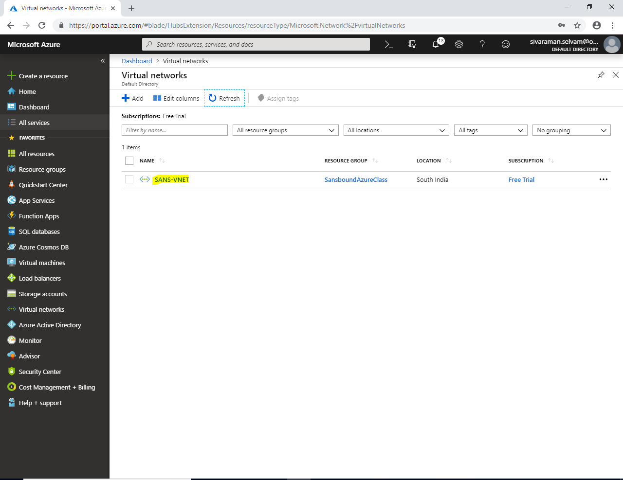

In **“Subnets”**

You are able to see the Subnet name as **“Sans-Pub-Subnet”** and address range for the Subnet is **10.0.2.0/24**.

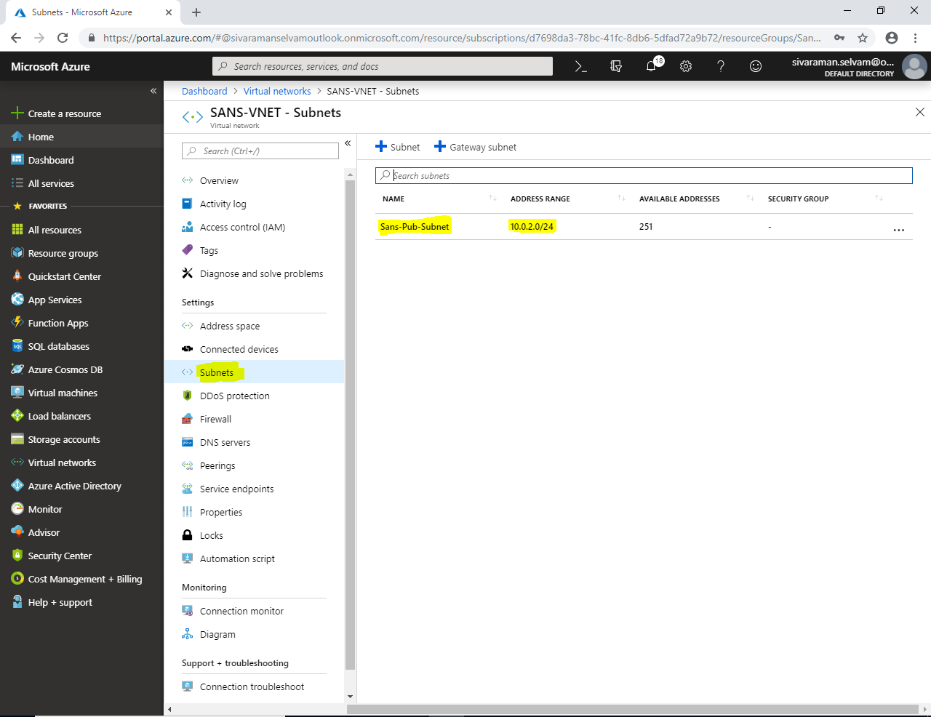

In Dashboard, click on **“Virtual machines”**.

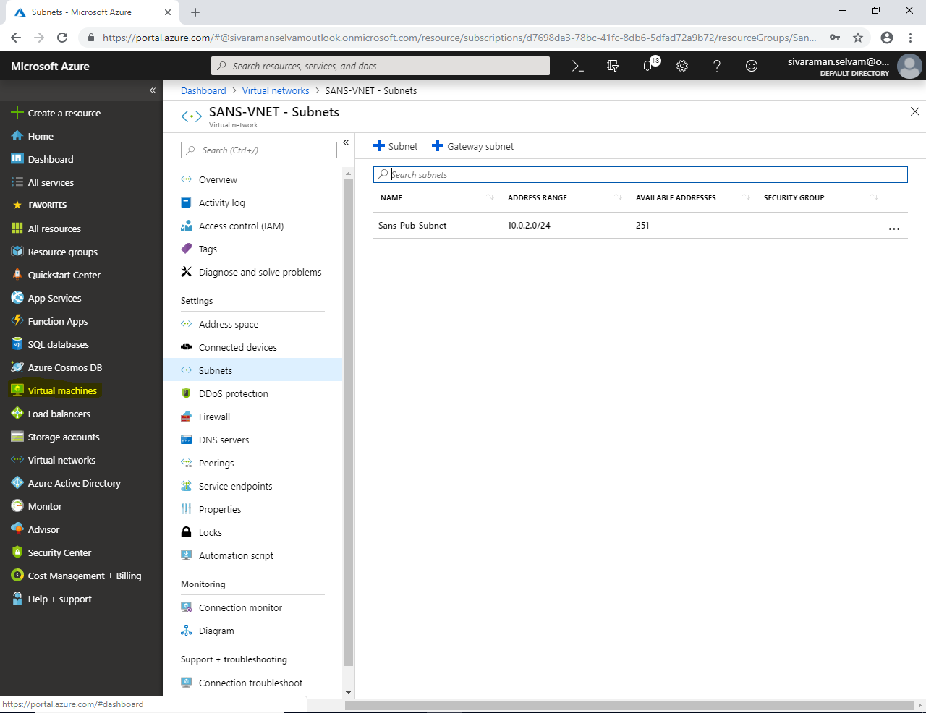

In **“Virtual machines”**

Click **“Add”** to create a new virtual machine.

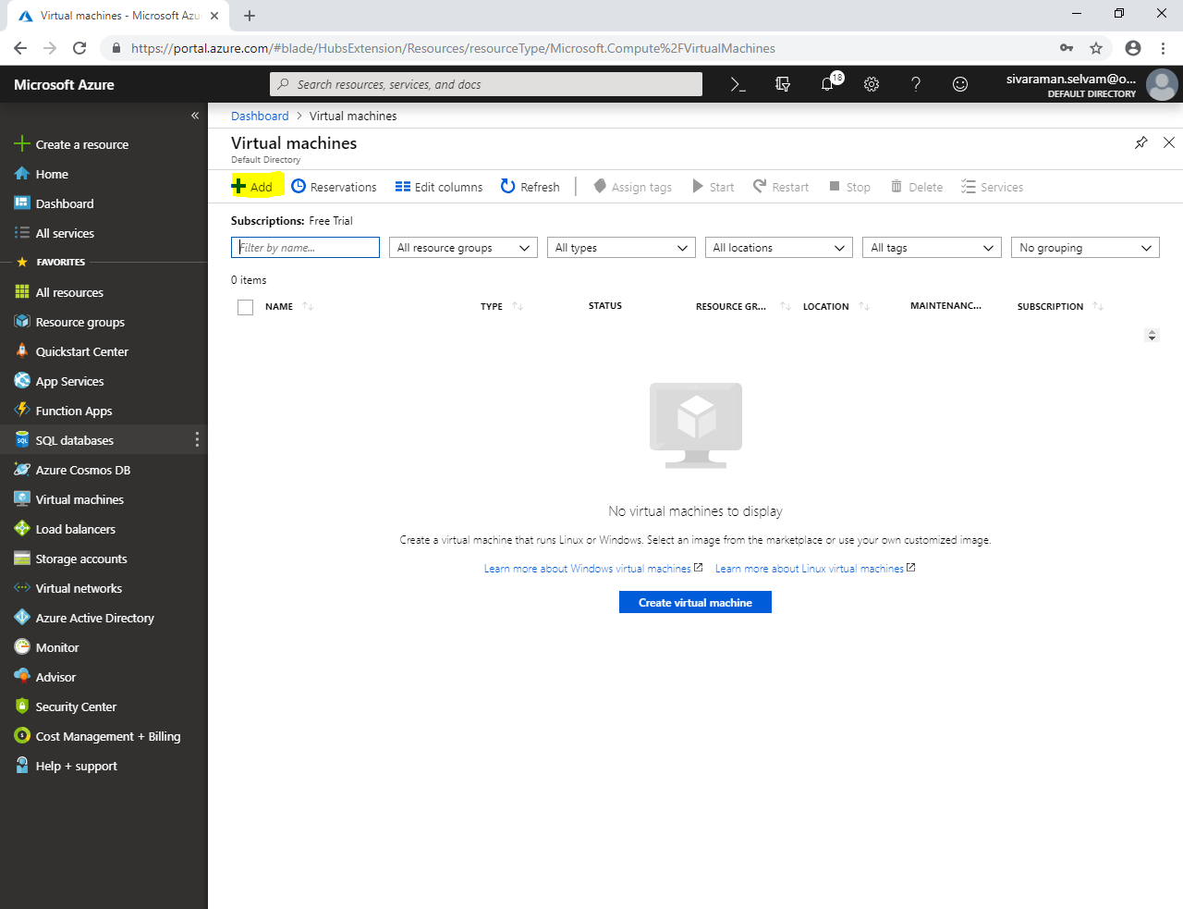

While creating **“Virtual machine”**,

Type **“Virutal machine name”** as **“WindowsVM-Azure”**.

Select **“Region”** as **“South India”**.

Select **“Image”** as **“Windows Server 2008 R2 SP1”.**

Change **“VM Size”** as **“Standard B1s”**.

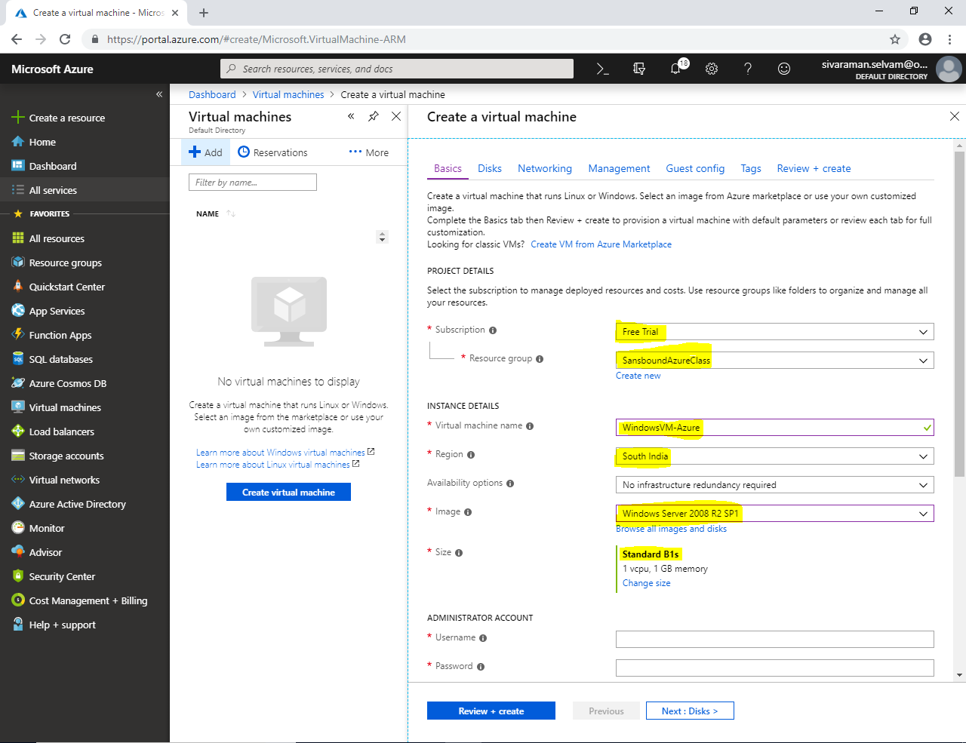

Click **“Administrator Account”**.

Type **“Username”** as sansbound and password as per your wish.

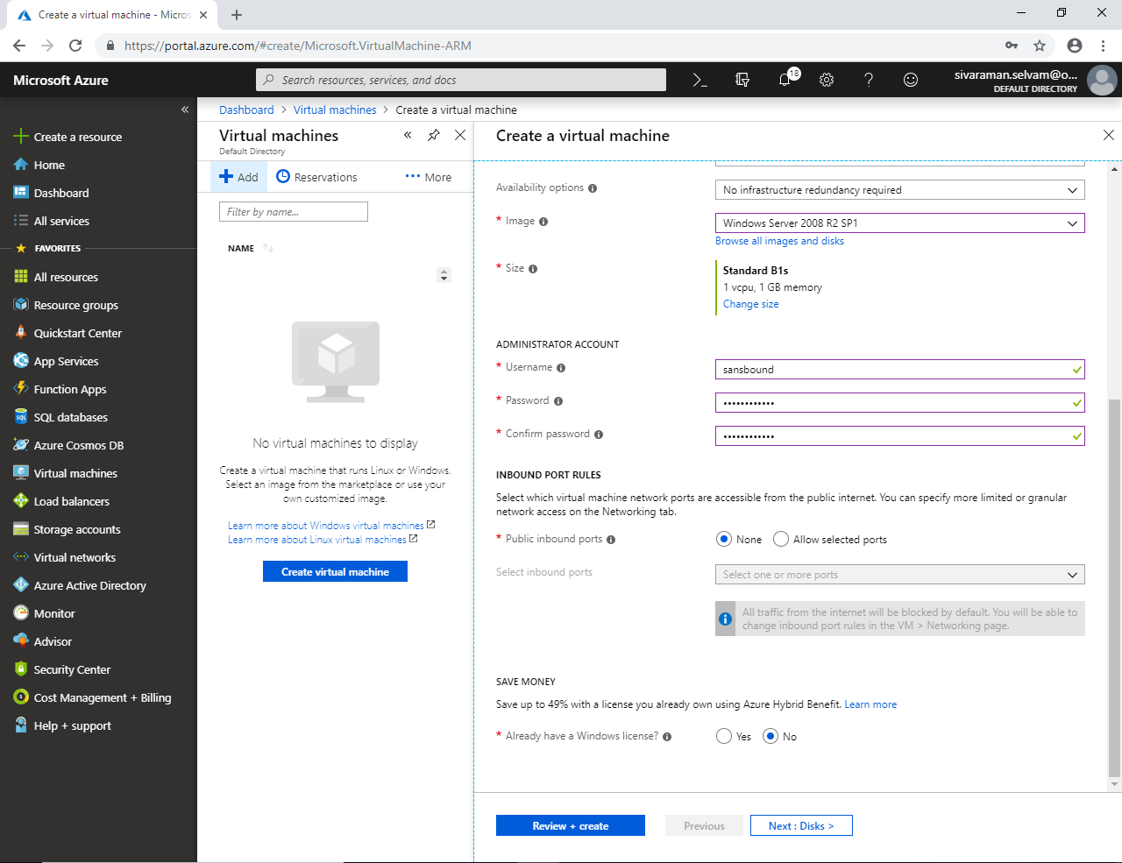

In **“Inbound Port Rules”**

Click **“Public inbound ports”** as **“Allow selected ports”**.

Select **“Select inbound ports”** as **“RDP”**.

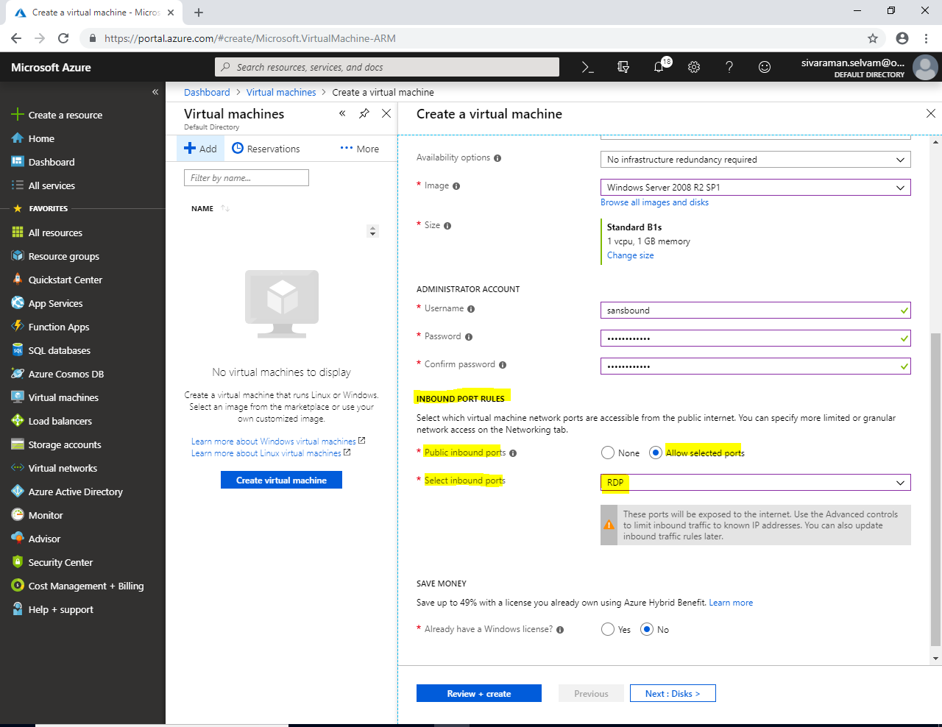

In **“Save Money”**

Click **“Yes”** for **“Already have a Windows license”**.

Click **“Confirmation”** check box.

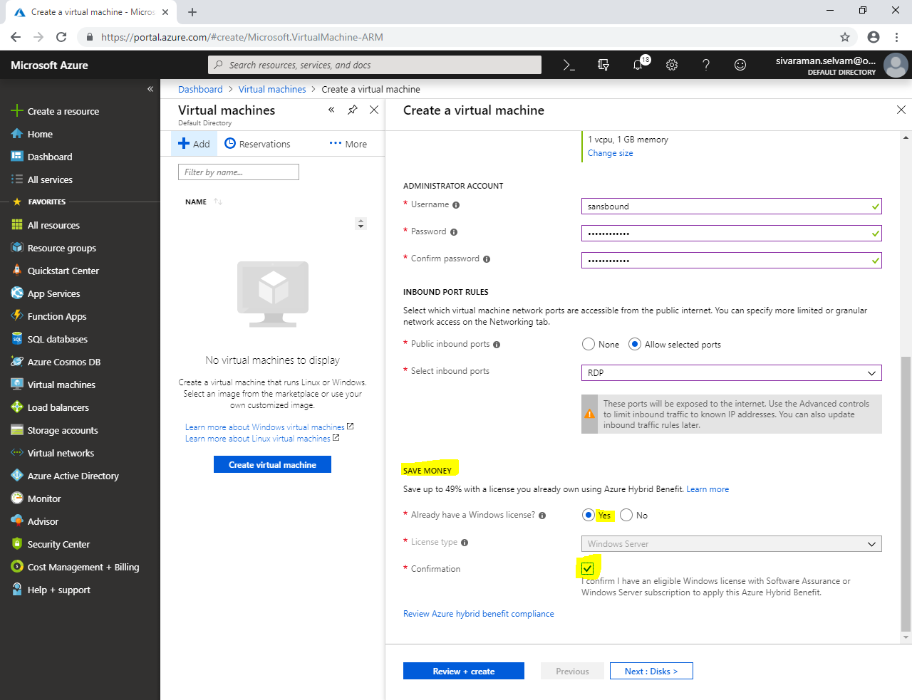

Click **“Next : Disks >”**.

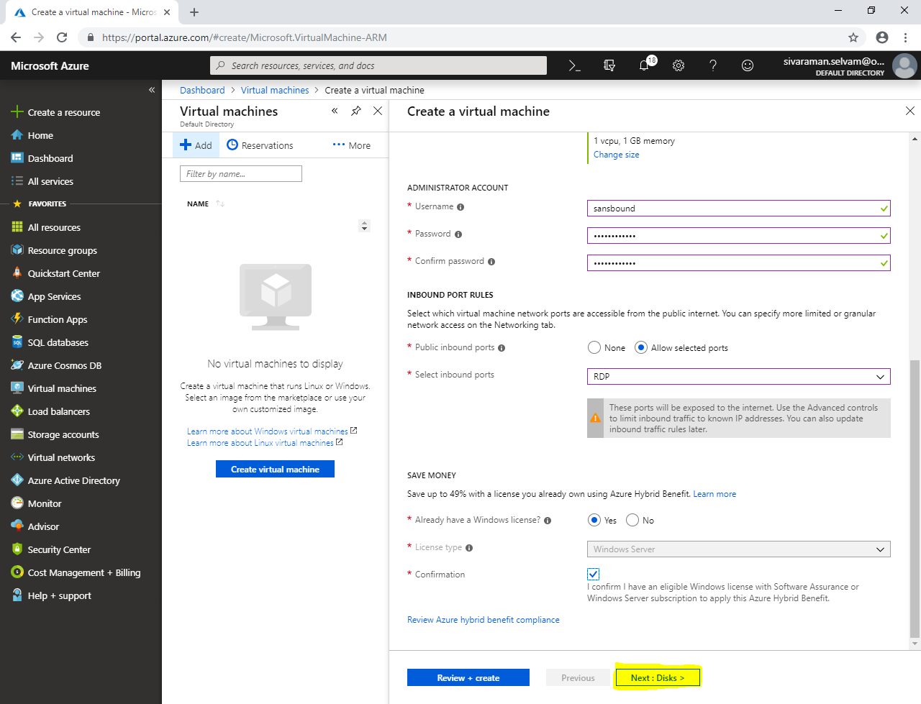

In **“Disks”**

By default **“Premium SSD”** as OS disk type to get high performance.

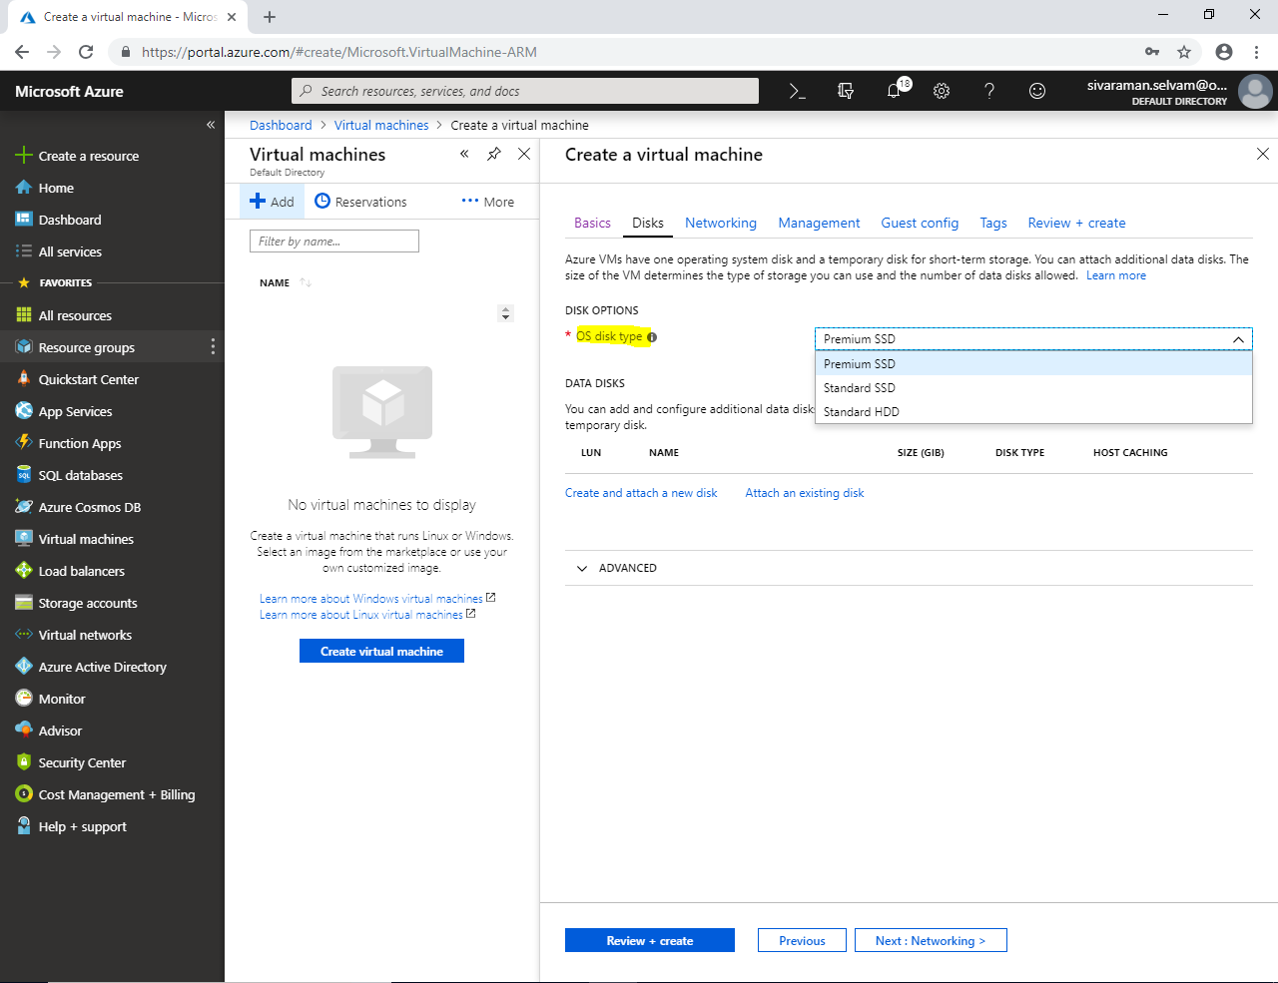

If you have selected OS disk type as **“Standard SSD”,** it clearly says that VM size supports premium disks. It recommended Premium SSD for high IOPS. And “Standard SSD” will not qualify for the 99.9% connectivity SLA. Compare Premium SSD disk performance will be slow.

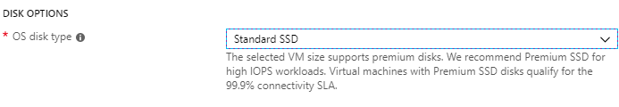

If you have selected OS disk type as **“Standard HDD”,** it clearly says that VM size supports premium disks. It recommended Premium SSD for high IOPS. And “Standard HDD” will not qualify for the 99.9% connectivity SLA. Compare Premium SSD and Standard HDD disk performance will be slow. It’s similar like as magnetic hard disk.

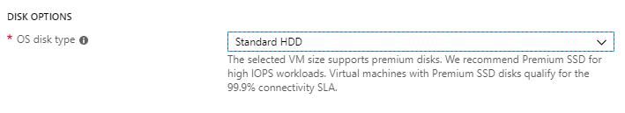

In **“Disks”**,

In **“Disk options”** select OS disk type as **“Premium SSD”**.

Click **“Next : Networking >”**.

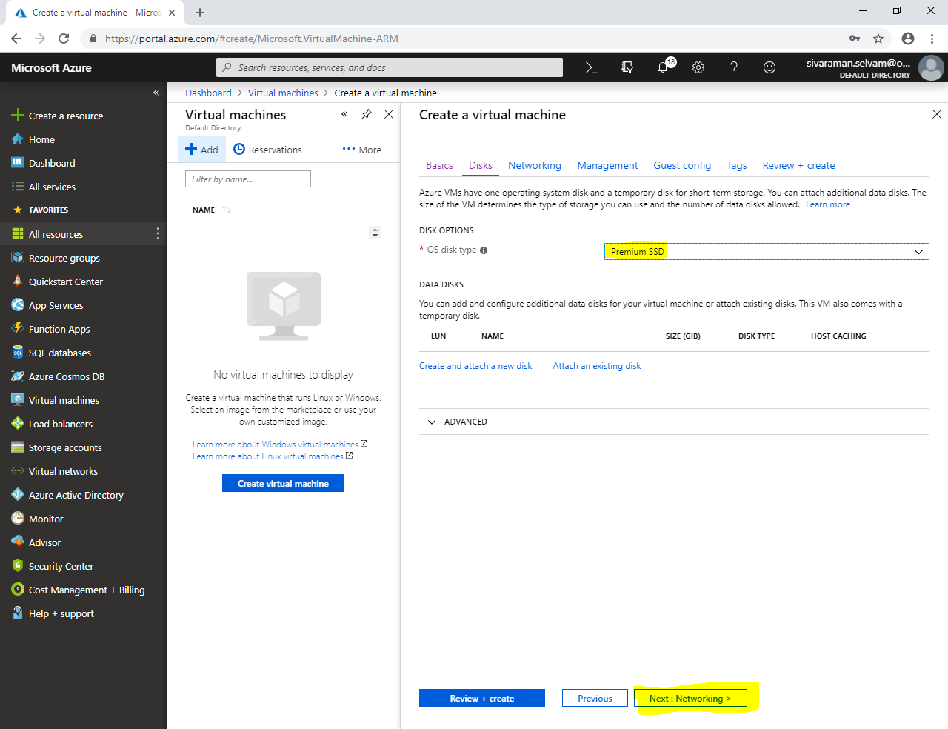

In **“Networking”**,

Click **“Next : Management >”**.

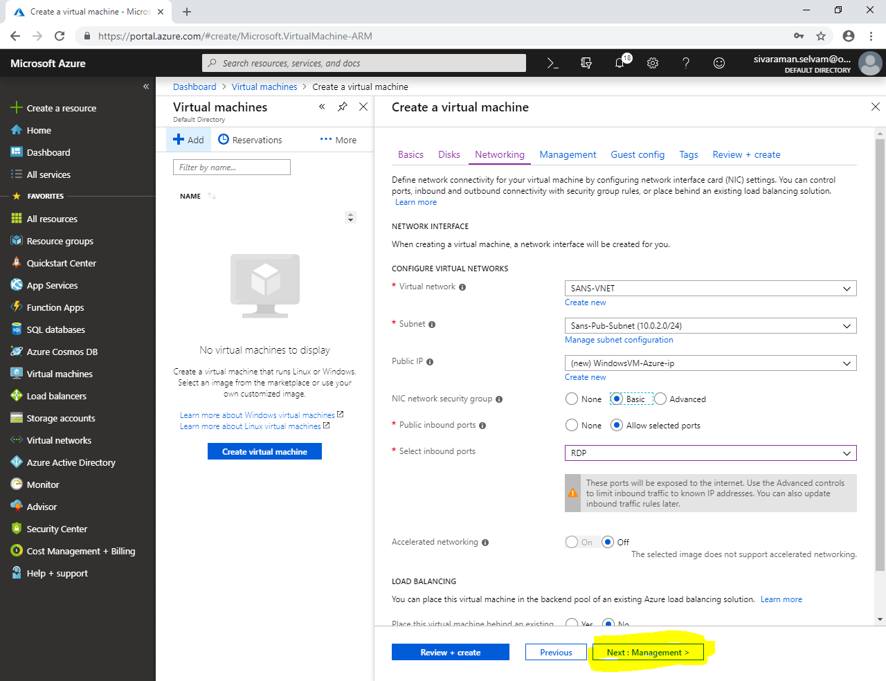

In **“Management”**,

Click **“Next : Guest config >”**.

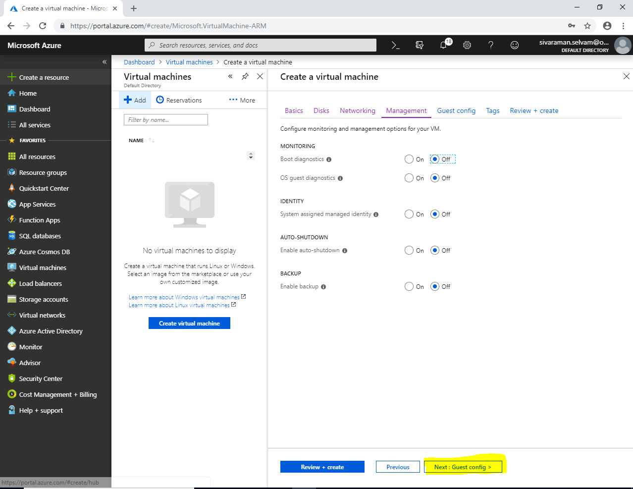

In **“Guest config”**,

Click **“Next : Tags >”**.

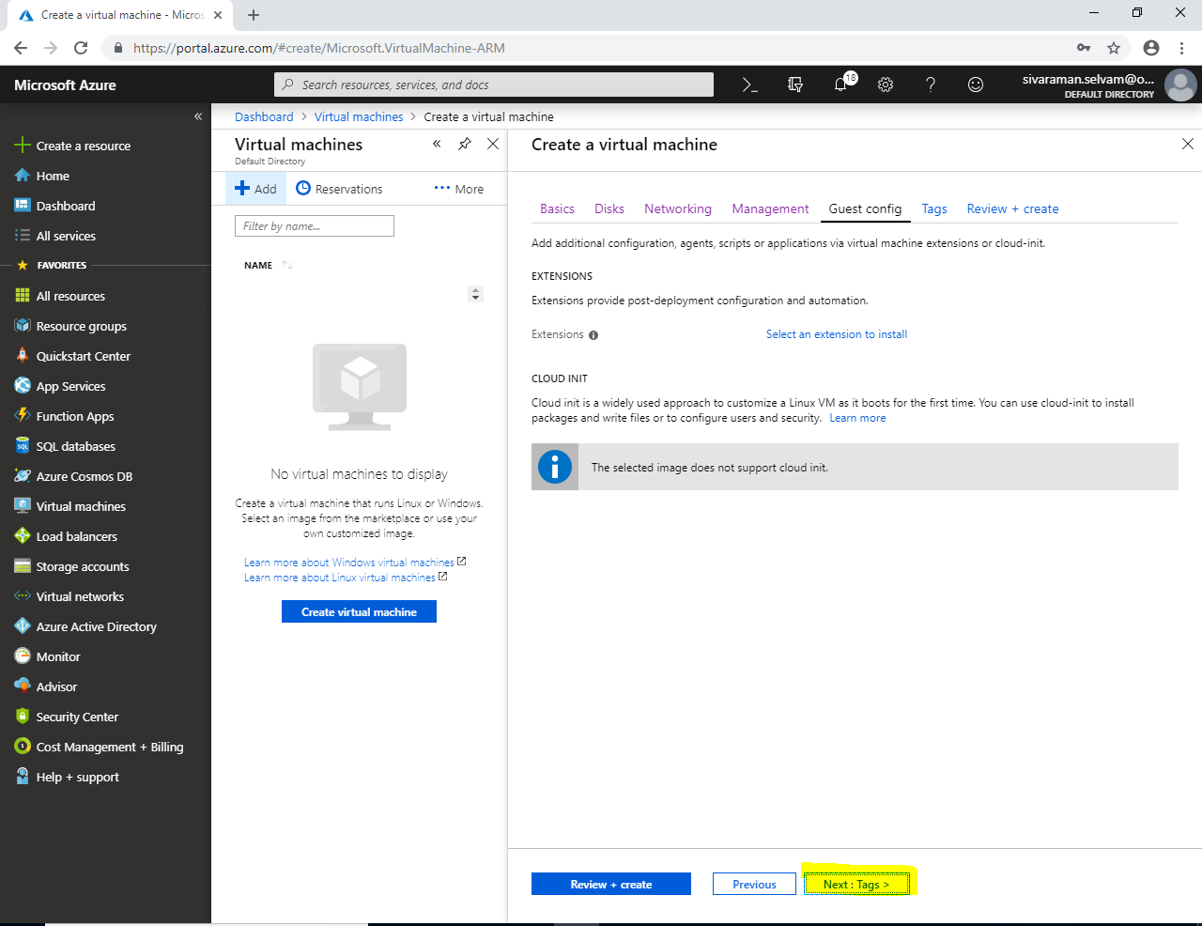

Click **“Next : Review + create”**.

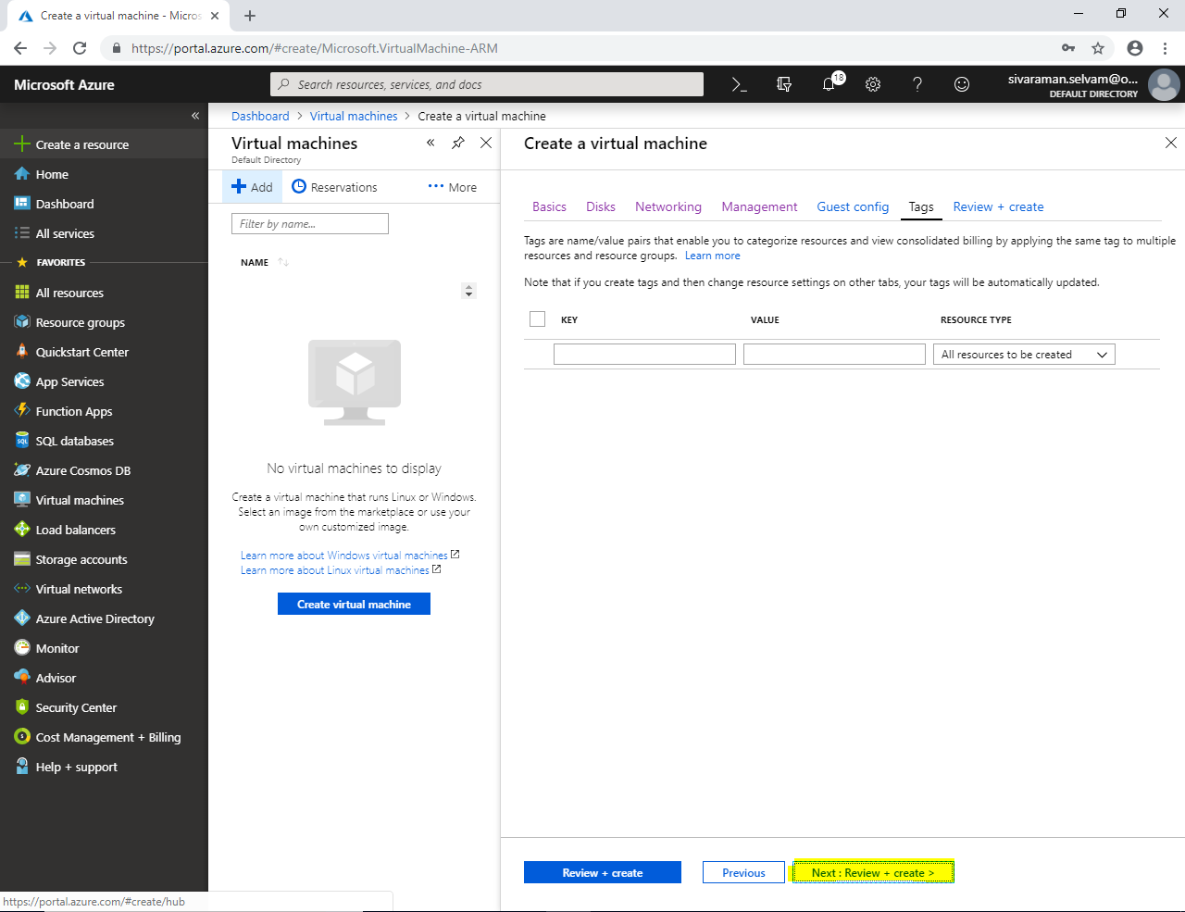

Click **“Create”**.

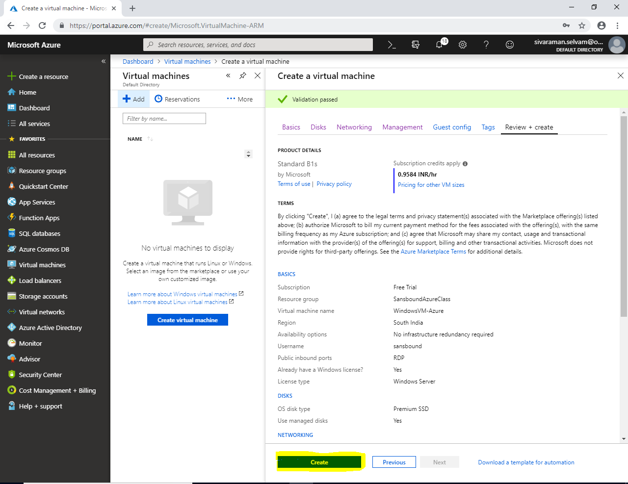

Click on **“Go to resource”**.

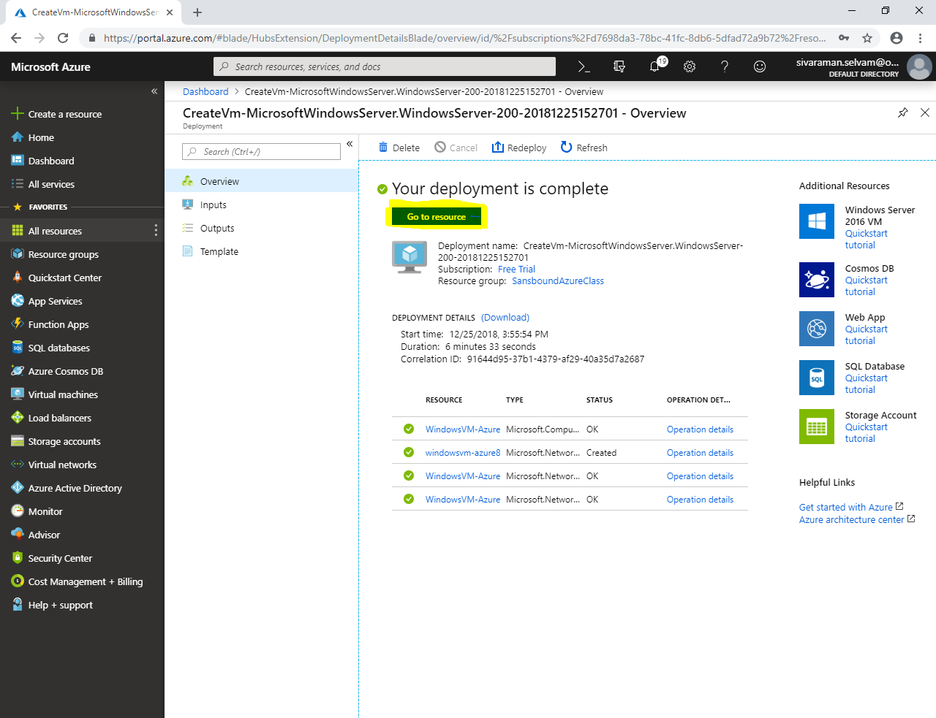

Kindly note the public IP address we will access the server by using RDP by using this Public IP Address.

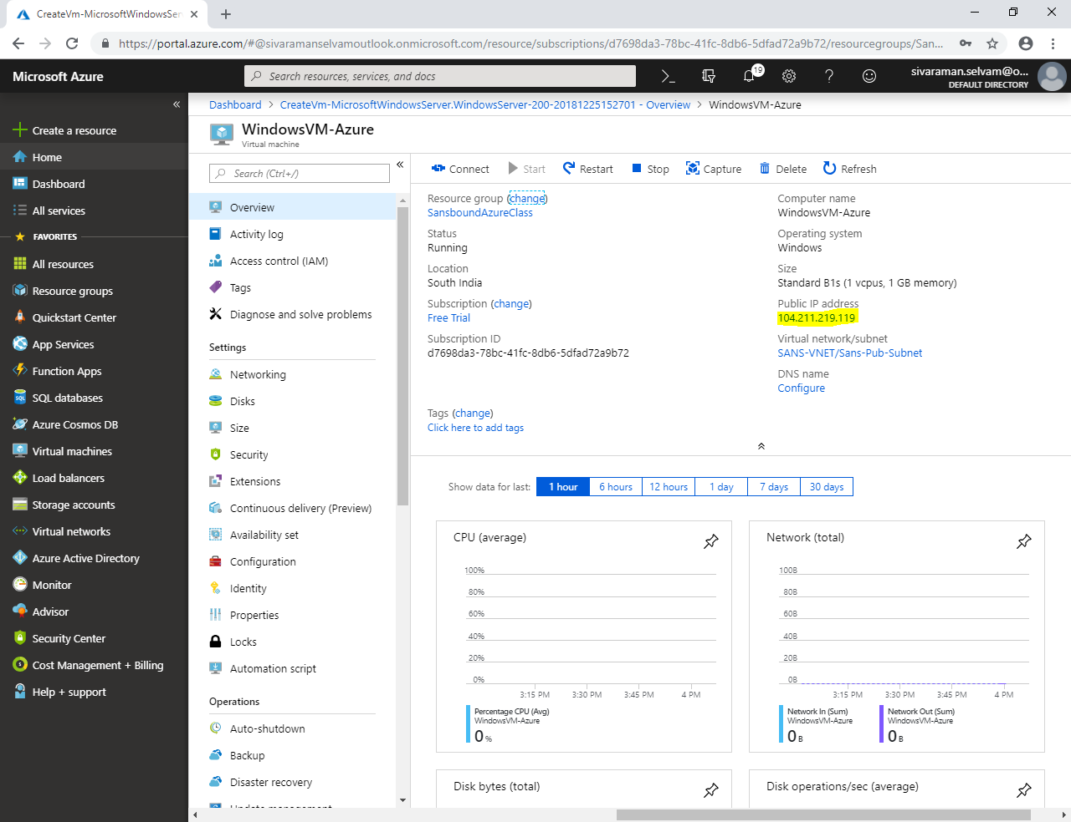

Type “mstsc” in Run box.

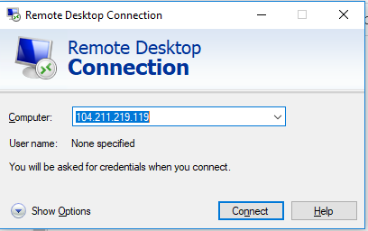

Click **“Connect”**.

Type **“Username”** and **“password”** for the Windows 2008 R2 Server virtual machine.

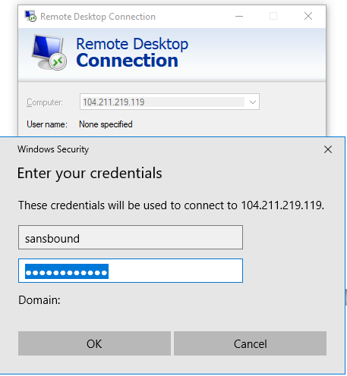

Click **“Ok”**.

Click **“Yes”.**

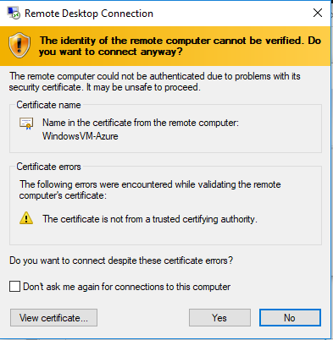

In “Windows Server 2008 R2” virtual machine,

You are able to see the **C drive space as “126 GB”.**

Also you are able to see another drive letter named **“D” (Temporary Storage).**

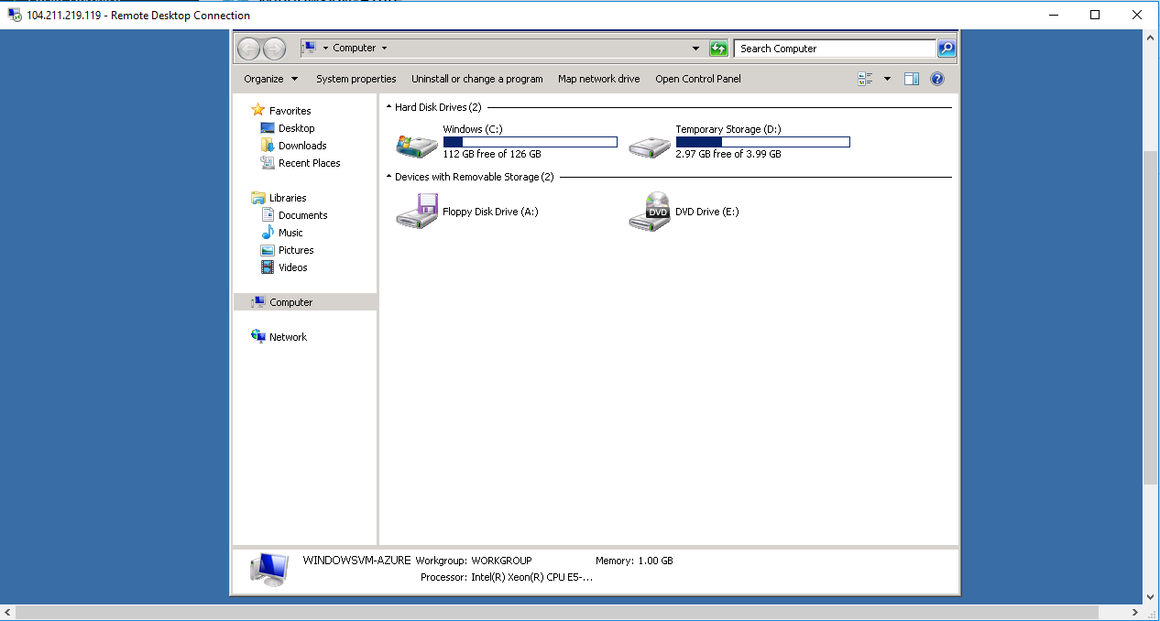

Click **“D” drive (Temporary storage):**

I can able to see one text file.

Open the text file.

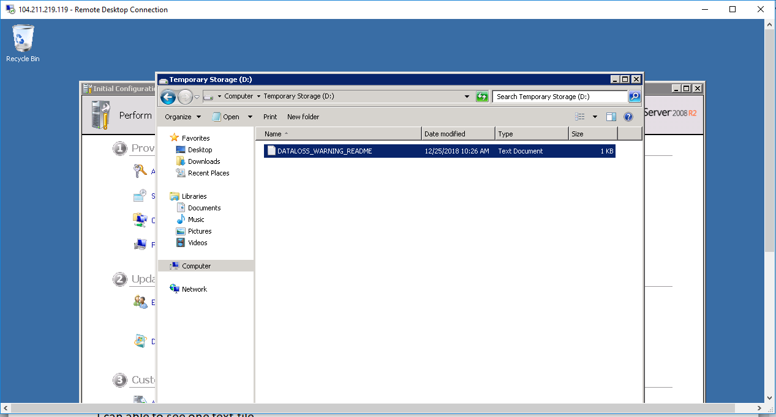

**It says that, do not store any data on this Temporary disk.**

